Министерство образования Республики Беларусь

Учреждение образования

“Брестский государственный технический университет”

Кафедра интеллектуально-информационных технологий

Лабораторная работа №6

“ MLP. Прогнозирование”

Выполнил:

студент 3 курса

группы ИИ-22

Копанчук Е. Р.

Проверил:

Туз И. С.

Брест 2023

Написать нейронную сеть(multilayer perceptron c одним скрытым слоем) для

решения задачи прогнозирования функции:

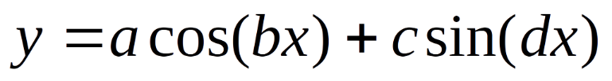

Обучить сеть с использованием константного и адаптивного шага обучения, online-

learning и batch-learning. Результаты для каждого варианта сети занести в таблицу(

test error, количество эпох, время обучения и тд)

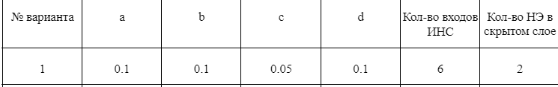

from matplotlib import pyplot as plt

import numpy as np

from sklearn.model_selection import train_test_split

from sklearn.metrics import accuracy_score, classification_report

from scipy.special import expit

import time

E_arr = []

class Perceptron :

def __init__(self, input_size, hidden_size, output_size, learning_rate = 0.05) :

self.input_size = input_size

self.hidden_size = hidden_size

self.output_size = output_size

self.learning_rate = learning_rate

self.start_rate = learning_rate

self.weights_input_hidden = np.random.randn(self.input_size, self.hidden_size)

self.bias_hidden = np.zeros((1, self.hidden_size))

self.weights_hidden_output = np.random.randn(self.hidden_size, self.output_size)

self.bias_output = np.zeros((1, self.output_size))

# print(self.weights_input_hidden)

# print(self.weights_hidden_output)

def sigmoid(self, x) :

return expit(x)

def sigmoid_derivative(self, x) :

return x * (1 - x)

def forward(self, inputs) :

self.hidden_input = np.dot(inputs, self.weights_input_hidden) + self.bias_hidden

self.hidden_output = self.sigmoid(self.hidden_input)

self.output = np.dot(self.hidden_output, self.weights_hidden_output) + self.bias_output

return self.output

def backward(self, inputs, target, output) :

error = target - output

delta_hidden = error.dot(self.weights_hidden_output.T) * self.sigmoid_derivative(self.hidden_output)

self.weights_hidden_output += self.hidden_output.T.dot(error) * self.learning_rate

self.bias_output += np.sum(error, axis = 0, keepdims = True) * self.learning_rate

self.weights_input_hidden += inputs.T.dot(delta_hidden) * self.learning_rate

self.bias_hidden += np.sum(delta_hidden, axis = 0, keepdims = True) * self.learning_rate

def train(self, inputs, targets, epochs: int, isAdapt : bool = False) :

global E_arr

for epoch in range(epochs) :

e_arr = []

for i in range(len(inputs)) :

input_data = np.array([inputs[i]])

target_data = np.array([targets[i]])

output = self.forward(input_data)

e_arr.append(target_data - output)

self.backward(input_data, target_data, output)

E2 = np.sum(np.array(e_arr) * *2) / 2

E_arr.append(E2)

self.learning_rate = self.start_rate * (1.0 / (1.0 + epoch / 100)) if isAdapt else self.learning_rate

#print(f"Online: Epoch: {epoch} MSE: {E2} LR: {self.learning_rate}")

def backwardBatch(self, inputs, targets, outputs) :

error = (targets.T - outputs).T

mse_batch = np.sum(error) / len(error)

inputs_cut = 0

for j in range(len(error)) : inputs_cut += error[j] * inputs[j]

mse_batch = np.array(mse_batch)

inputs_cut = np.array(inputs_cut).reshape(1, -1)

delta_hidden = mse_batch.dot(self.weights_hidden_output.T) * self.sigmoid_derivative(self.hidden_output)

self.weights_hidden_output += self.hidden_output.T.dot(mse_batch) * self.learning_rate

self.bias_output += np.sum(mse_batch, axis = 0, keepdims = True) * self.learning_rate

self.weights_input_hidden += inputs_cut.T.dot(delta_hidden) * self.learning_rate

self.bias_hidden += np.sum(delta_hidden, axis = 0, keepdims = True) * self.learning_rate

def trainBatch(self, inputs, targets, epochs: int, batchsize : int, isAdapt : bool = False) :

global E_arr

if (len(inputs) % batchsize != 0) :

print("Плохое значение пакета")

return ValueError

inputspack = [inputs[i - batchsize:i] for i in range(batchsize, len(inputs), batchsize)]

targetspack = [targets[i - batchsize:i] for i in range(batchsize, len(targets), batchsize)]

for epoch in range(epochs) :

e_arr = []

for i in range(len(inputspack)) :

outputs = [self.forward(batchElem).item() for batchElem in inputspack[i]]

for j in range(len(targetspack[i])) : e_arr.append(targetspack[i][j] - outputs[j])

self.backwardBatch(inputspack[i], targetspack[i], outputs)

E2 = np.sum(np.array(e_arr) * *2) / 2

E_arr.append(E2)

self.learning_rate = self.start_rate * (1.0 / (1.0 + epoch / 100)) if isAdapt else self.learning_rate

#print(f"Batch: Epoch: {epoch} MSE: {E2} LR: {self.learning_rate}")

def predict(self, inputs) :

output = self.forward(inputs)

return output

if __name__ == "__main__" :

import csv

epochs = 100

X, Y = [], []

with open(r"D:\diabetes.csv") as file :

reader = csv.reader(file)

for i, row in enumerate(reader) :

X.append([float(value) for value in row[:-1]])

Y.append([float(row[-1])])

X = np.array(X)

Y = np.array(Y)

X /= 1000

X_train, X_test, y_train, y_test = train_test_split(X, Y, test_size = 0.2, random_state = 42)

perceptron = Perceptron(8, 1, 1)

start = time.time()

perceptron.train(X_train, y_train, epochs, False)

end = time.time()

temp = perceptron.predict(X_test)

y_pred = (temp > 0.5).astype(int)

accuracy = accuracy_score(y_test, y_pred)

print(f"Time taken: {(end-start):.03f}s")

print(f"Точность модели : {accuracy:.2f}")

print(f"Точность модели (MSE) : {min(E_arr):.10f}")

plt.plot(range(epochs), E_arr, '-')

E_arr.clear()

print(classification_report(y_test, y_pred, zero_division = 1))

perceptron = Perceptron(8, 1, 1)

start = time.time()

perceptron.train(X_train, y_train, epochs, True)

end = time.time()

temp = perceptron.predict(X_test)

y_pred = (temp > 0.5).astype(int)

accuracy = accuracy_score(y_test, y_pred)

print(f"Time taken: {(end-start):.03f}s")

print(f"Точность модели: {accuracy:.2f}")

print(f"Точность модели (MSE) : {min(E_arr):.10f}")

plt.plot(range(epochs), E_arr, '--')

E_arr.clear()

print(classification_report(y_test, y_pred, zero_division = 1))

perceptron = Perceptron(8, 1, 1)

start = time.time()

perceptron.trainBatch(X_train, y_train, epochs, 2, False)

end = time.time()

temp = perceptron.predict(X_test)

y_pred = (temp > 0.5).astype(int)

accuracy = accuracy_score(y_test, y_pred)

print(f"Time taken: {(end-start):.03f}s")

print(f"Точность модели: {accuracy:.2f}")

print(f"Точность модели (MSE) : {min(E_arr):.10f}")

plt.plot(range(epochs), E_arr, '-.')

E_arr.clear()

print(classification_report(y_test, y_pred, zero_division = 1))

perceptron = Perceptron(8, 1, 1)

start = time.time()

perceptron.trainBatch(X_train, y_train, epochs, 2, True)

end = time.time()

temp = perceptron.predict(X_test)

y_pred = (temp > 0.5).astype(int)

accuracy = accuracy_score(y_test, y_pred)

print(f"Time taken: {(end-start):.03f}s")

print(f"Точность модели: {accuracy:.2f}")

print(f"Точность модели (MSE) : {min(E_arr):.10f}")

plt.plot(range(epochs), E_arr, ':')

plt.legend(['Online-Const', 'Online-Adapt', 'Batch-Const', 'Batch-Adapt'], loc = "upper right")

plt.show()

print(classification_report(y_test, y_pred, zero_division = 1))

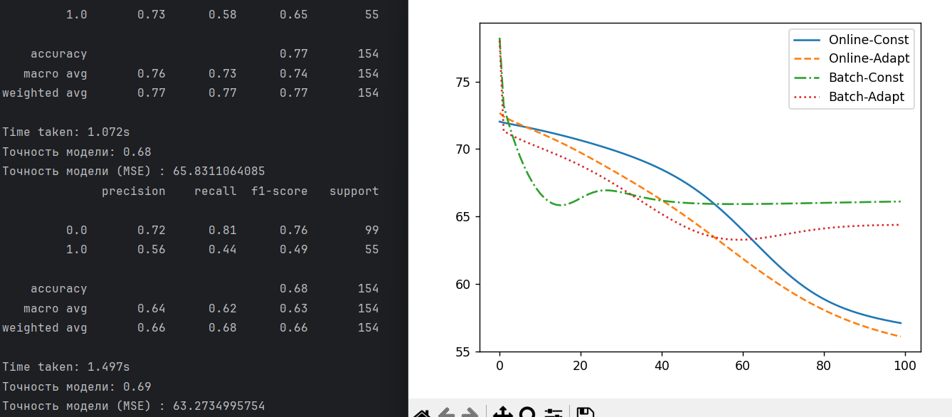

Вывод: изучил обучение и функционирование ИНС при решении задач прогнозирование.